Name Li Jiajun | 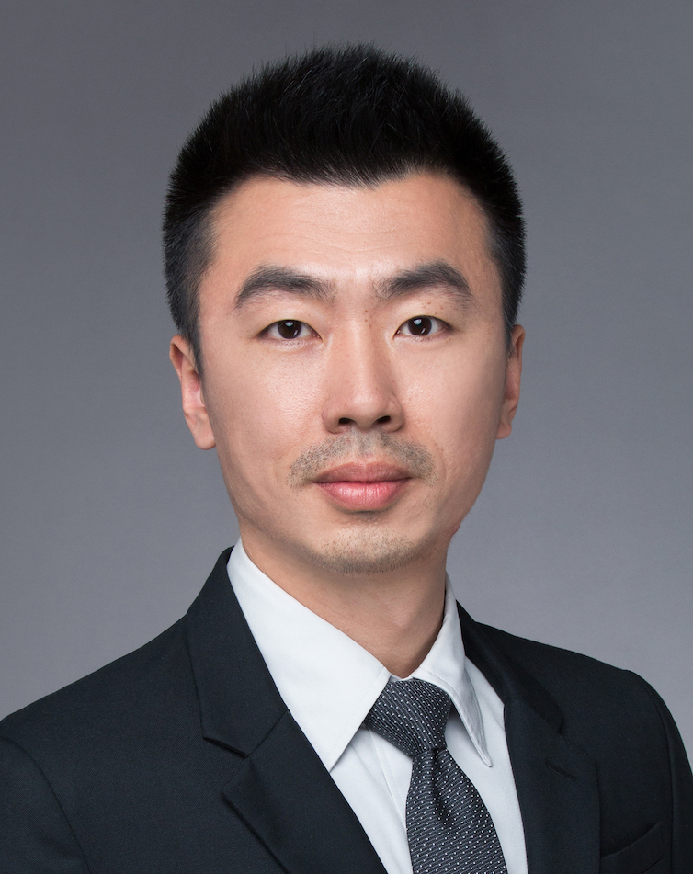
Gender Male
Birthday 1983.12
Location Shanghai
Status Married
Education background
2002.09 – 2006.07.20 Shanghai Maritime University Marine engineering
Major & degree Bachelor in Engineering

Working Experience
2016.02 – Now Planning and Logistics Department Shanghai Volkswagen Powertrain Co.,Ltd
Position Expert of demand & supply resource management (Manager Level.3)
- Lead and manage the team of resource management to achieve the annual objective
- Capacity & risks management
- Manage whole supply chain for ensure adequate resource supply.
- Member of China region’s EA211 resource management team, with the colleagues from VGC, SAIC-VW, FAW-VW PU & LO department.
- Attend the Production meeting & report the supply chain risks to the top management team.
- In charge of the “Site Visit Team (SVT)” with Quality, Logistics, Purchasing, visit the supplier to support and solve the problems in house at their plant.
- Analysis resource status to direct the localization and supply strategy.
- Support the capacity launching and ramp-up of new project and new supplier.
- Tracking and monitoring the supply chain risk, review and approve the “Risk Part Weekly Report” with the team.
- Enquiry the supply chain capacity status, check summary report and make the draft solutions.
- Check and make the backlog plan along with the demands fluctuating and cost effectiveness.
- Set risk enquiry plan, supervise team member to release the info and check the summary report.
- Supply chain operational management
- Arrange team member to make the Supplier KPI (VW-SRS) of supply chain operation.
- Make the supply rating process and define the evaluate KPI range.
- Support the key supplier to make the preparation of production along with powertrain strategy of VW China. (Successfully launched switch from EA111 to EA211；Replaced all original MPI engines by 1.5L engine, and so on.)
- Be the team member of VWPT-KTM² with cross function team from PU, QA and Project to manage the supply chain.
- Mold & tooling management
- Making the budget of molds to along the forecast strategy.
- Together with PU, allocate the molds cost (VWPT & FAW-VW), And maintain the cost information into systems.
- Manage all molds as fixed assets and check the checking report from team member.

- SRS (Supplier Rating System) online implementing project (2016)
Be the responsible person, participated the whole project to ensure the system online on time finally. Also, all the JVs of China region are using this rating system for logistics KPI.
Performance: This system optimizes the level of logistics’ operation. The average KPI rating was be increased from Note 87 (Mar.2016) to Note 92 (Dec. 2016).
- Project of risk of supply chain summary（2016年）
Be the responsible person, participated the whole project.
The target of this project is to analysis the data of supplier chain risk from 2009 to 2015. Then try to find some logics in these cases for supplier management in the future.
Performance: For example: "Remark the schedule of risk enquiry plan, added some details in it. Then to decreased the risk parts finally. The quantity of 2016 risk parts was less than the average quantity from 2009 to 2015, about 25%.
2009. 07– 2016.02 Planning and Logistics department Shanghai Volkswagen powertrain Co.,Ltd
Position Officer of demand & supply resource management
- Risk part controlling
- Make and send the critical parts report
- Attend the China region risk resource regular meeting, cooperate with VGC, SAIC-VW, FAW-VW LO & BU to discuss the solutions to solve engine supplier chain problem.
Tracking the long-term risk parts for production, delivery and stock level.
- Capacity management of supplier
Visit the supplier plant for risk parts, to find the production process problem on site. Especially for Casting and foundry suppliers.
- The project of Cam raw part localization (2015)
Support to analysis of capacity and gap
This project broken the monopoly of CKD cam in EA211 engine. Also to solve the capacity problem about cam raw part is not enough for VW China in 2015. Finally the new supplier Jiangsu Sunway started to delivery, the PPAP was successful.
Performance: The project got the award of “the key quality achievement”. 2nd class. No. 2016010043

2006. 07– 2009.06 Planning and Logistics Department Shanghai Volkswagen Powertrain Co.,Ltd
Position Local parts disposition
- Release the weekly order for suppliers
- Manage the delivery and operation of suppliers.
- Manage the inventory level along inventory costs and security of supply.
- Release the 12 weeks rolling forecast
- Track the risk parts delivery

Skills & Others

Language Chinese & Shanghainese: Native
English： Fluent in listening; Speaking; Reading; Writing
Certification - Process-Auditor to VDA6.3 Issuing Date：2011,10,21 Shanghai
No：CN/6.3/1011016 Issuing authority：VDA
- Internal Process Auditor Date：2006,8,13 Shanghai
Issuing authority：TÜV
PC ability MS-Office, SAP, ERP
Driving license C1

